**GRAINS**

**HERO**

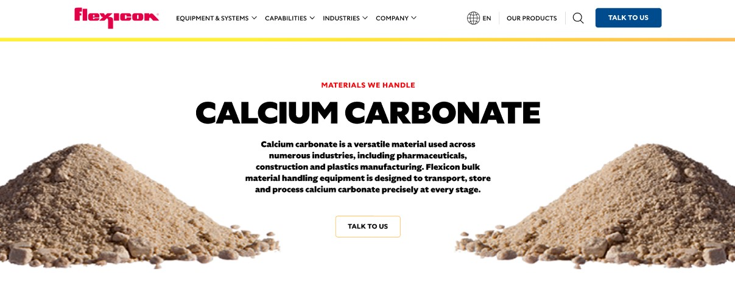

Grains are the harvested seeds of grasses such as wheat, oats, rice, and corn and are essential staples that feed the world. They provide a vital source of energy and nutrition for both people and animals, as well as raw materials for industrial products and fuels. Flexicon bulk material handling equipment is engineered to move, store, and process grains efficiently while preserving quality.

**Button**: Talk To Us

**SHELF #1 - PRODUCT DESCRIPTION**

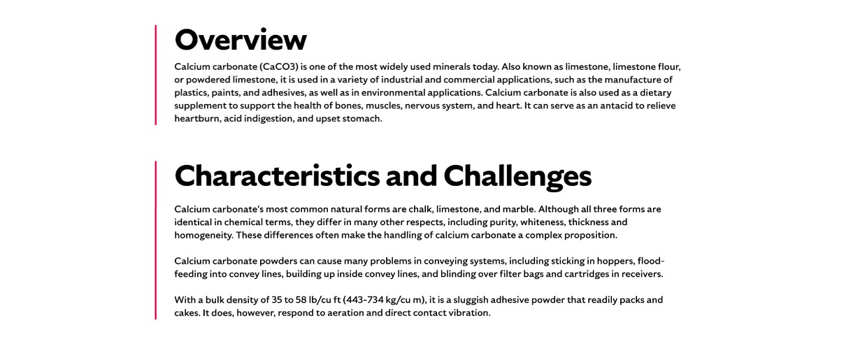

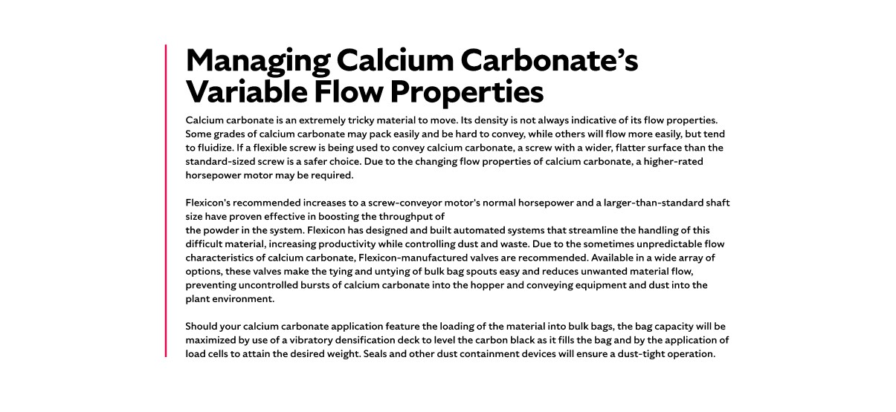

* **Overview**Rice, corn, and wheat are the world’s most important staple foods, supplying nearly half of global calories. Other grains like sorghum, millet, rye, and barley also play a vital role in human diets and animal feed. Beyond nutrition, grains are used to make cooking oils, cosmetics, alcoholic beverages, and industrial products such as biofuels. They are also key to global trade and economic stability, supporting livelihoods from small-scale farmers to major agricultural industries.
* **Characteristics and Challenges**Grains are generally marketed in whole form, with quality judged heavily on their appearance and structural integrity. Breakage during harvesting, drying, or handling can reduce market value, lower milling yield, and increase susceptibility to pests and spoilage during storage. The size, shape, and hardness of grains vary widely between types, affecting flow behavior and processing requirements. Moisture content is another critical factor, as excess moisture can promote mold growth, while overly dry grains are more prone to fissures and cracking. Maintaining consistent grain quality demands gentle handling, proper storage conditions, and equipment designed to minimize physical damage.

Grain dust presents one of the most serious hazards in grain handling operations due to its high combustibility, posing risks of fires and explosions if it accumulates and encounters an ignition source. Facilities must control both dust levels and ignition risks to meet safety regulations and prevent catastrophic incidents. Additional operational issues include material flow problems such as bridging, rat-holing, and flooding, which can lead to spillage, processing delays, and equipment wear. Grain fines are particularly troublesome, as they can become airborne, create hazardous working conditions, and cause product loss. To address these challenges, grain must be conveyed at controlled speeds, with equipment that minimizes dust generation and reduces mechanical stress on the product.

**SHELF #2 - FLEXICON SOLUTIONS**

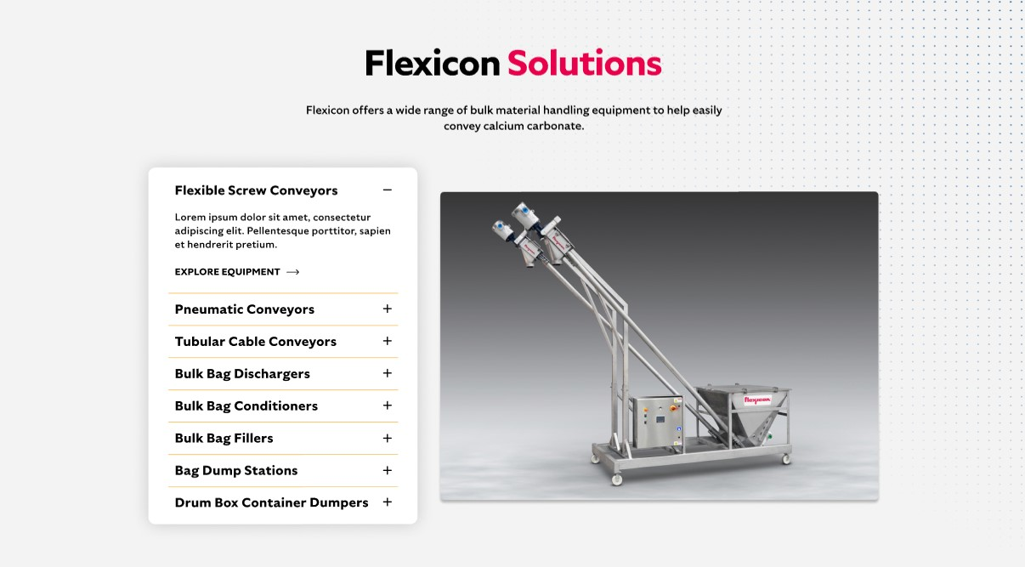

**Flexicon Solutions**

Flexicon offers a wide range of bulk material handling equipment to help easily convey calcium carbonate.

* **Flexible Screw Conveyor**: Move grain gently at controlled speeds to reduce breakage and dust.
* **Pneumatic Conveyors**: Transport grains pneumatically, minimizing dust and preventing contamination.
* **Tubular Cable Conveyors**: Handle grains delicately using low-speed, enclosed cable systems.
* **Bulk Bag Dischargers**: Provide dust-tight unloading from bulk bags with flow-promotion features for complete discharge.
* **Bulk Bag Conditioners**: Loosen compacted grains in bulk bags to restore free-flowing movement.
* **Bulk Bag Fillers**: Fill bulk bags efficiently while containing dust and maximizing bag capacity.
* **Bag Dump Stations**: Allow safe, dust-controlled manual emptying of grain bags into processing systems.
* **Drum Box Container Dumpers**: Empty grain from drums, boxes, or containers into receiving equipment with minimal spillage.

**SHELF #3: LIFETIME PERFORMANCE GUARANTEE**

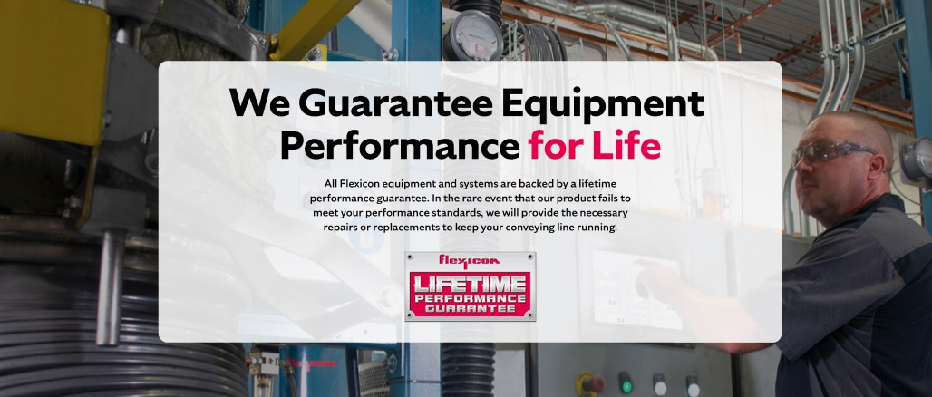

**Lifetime Performance Guarantee**

All Flexicon equipment and systems are backed by a lifetime performance guarantee. In the rare event that our product fails to meet your performance standards, we will provide the necessary repairs or replacements to keep your conveying line running.

**SHELF #4: CASE STUDIES**

